**COMP 3067 -- Computer Graphics**

**Project: Design a Visualisation System for Visualising Data**

**Release Date: *21 March 2019 (Thursday)***

**(Weightage to final grade is 20%.)**

## Description

The project requires you to do the programming to create a data/information visualisation software system. You need to **pair up with another student to form a group**; and each group does the collaboration together to finish the work. Your group may decide the content of the visualisation system you create, which may contain some static charts and diagrams, some interaction and/or some small animations. Kindly note that **as you work in a group** of two persons, please remember to **accomplish more work, for example more tasks and/or more operations, in your visualisation system**.

Moreover, you may use **all different kinds of softwares or programming languages (Eg. C++ with OpenGL, Javascript, Python, Java, R, Matlab, … etc)** to accomplish the objective. Furthermore, you need to find yourselves one data set (or one kind of data sets) as the input to your visualization system; and the data set should be of considerable size, say not too small, so that performing some meaningful and useful visualisation operations onto the data set becomes a very interesting and challenging task. Thus you need to design your visualization system (may be 2D or 3D) very well so that it is very appropriate for visualising the input data set of yours. A reference list of web-links for finding some data sets are as follows:

* [An archive of datasets distributed with the R statistical language](https://vincentarelbundock.github.io/Rdatasets/)
* [Office for National Statistics (UK)](https://www.ons.gov.uk/)
* [Machine learning data set repositories](http://archive.ics.uci.edu/ml/)
* [30 Places to Find Open Data on the Web – Visual.ly](http://blog.visual.ly/data-sources/)
* [World Bank Data Catalog](http://data.worldbank.org/data-catalog)
* Etc …

The purpose of this proposed project is for you to demonstrate your knowledge of data/information visualization techniques taught in the lectures and/or what you learn from other various sources. We also give credits for your creative ideas being contributed in your visualization project. Some example data/information visualization systems are as follows:

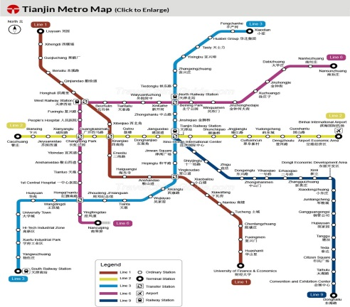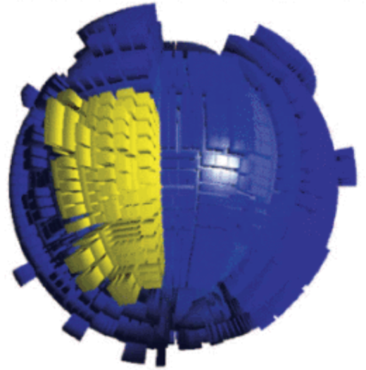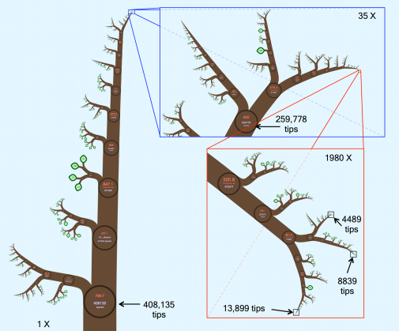

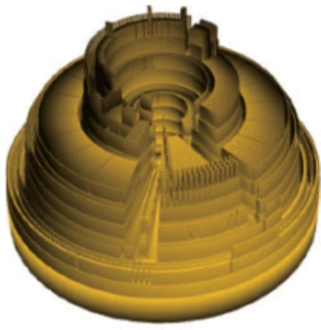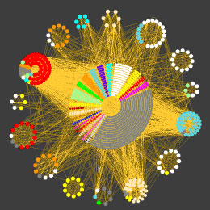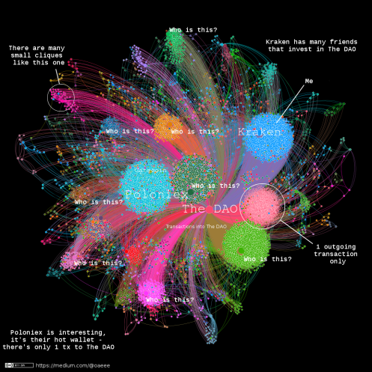

You are required to create data/information visualisation system with the majority of the following items:

(although you may put more emphasis on a specific item among all of these.)

* + Some static visualisation charts and/or diagrams;
  + Some interactive operations,
  + ~~Some small animated operations~~, (**optional, NOT required ..**)
  + Some other interesting operations of your choices,
  + Some your own interesting creative ideas in creating the information visualisation system.

## Proposal

In the first one or two weeks, you need to submit a **3-page draft proposal**, which should contain the list of group members in your group, the topic for the visualistion system for your group, and what you propose to do in your proposed information visualisation system (although you could deviate a bit when you are progressing in doing your project).

1. Form a group of two persons.
2. Give a brief description on the visualisation system you propose to create.

**(5% marks)**

**Submission Due Date: 4:00pm, 2 April, 2019 (Tuesday) – UK time**

**File name: FIV_2019_ StudentName_IDNumber _Proposal.pdf**

## Full Program and Report

Then after several weeks, you need to submit a zip file including: source code, full report, and readme.doc file.

* + **Full report** **- 35%**: (**around 8 to 16 pages, up to your preference**) + **readme.doc** - **5%** (**around one to two pages, up to your preference**)

The final full report will be an implementation of the proposed solution (Code repositories) and a 8-16 page paper written in the format of a conference paper submission. **Template can be found at this**[**page**](http://junctionpublishing.org/vgtc/Tasks/camera.html)(*Here, we more recommend you to use LaTeX template*) and it is **required** for you to use this template to write your report. *There is no length restriction, feel free to use as much space as you need for images.* 

The **written report** is expected at the end of the project, which includes:

* Introduction: An explanation of the problem and the motivation for solving it.
* Related work: A description of previous papers related to your project.
* Methods/Design (storyboard, etc.): A detailed explanation of the techniques and algorithms you used to solve the problem.
* Implementation (must include specifics of what other components/libraries you built upon): A detailed explanations on how you implement the visualization.
* Results: detailed description of your visualizations
* Evaluation (e.g. user study or reflections/discussion of your system): The visualizations your system produces and data to help evaluate your approach. For example you may include running times, or the time users typically spend generating a visualization using your system.
* Discussions: What has the audience learned from your work? What new insights or practices has your system enabled? A full blown user study is not expected, but informal observations of use that help evaluate your system are encouraged.
* Conclusions and Future Work: A recap of take-aways and detailed description of how your system could be extended or refined.
* Bibliography or References

In addition, please also submit a simple document file (one or two pages) **(5%)**, **readme.doc**, briefly describing how to use your program, how you meet the requirements of the project, and your creative ideas contributed in creating the scene. Note that in this document readme.doc, you *MUST* include a screenshot picture of your full scene you produced in your program.

**(40% marks)**

* + **Source Code** - **45%**:

Apart from the requirements **(40%)** described in the Description section, some minor credits **(5%)** are given for accounting for the readability, good structure and good style of source code you write.

**(45% marks)**

**Submission Due Date: 4:00pm, 1 May 2019 (Wednesday) – UK time**

**File names:**

**Zip file: FIV_2019_StudentName_IDNumber_Project.zip,** which contains the following files**:**

**1. Souce Code of Program: Note that you are free to name the files(“.cpp”, “.h”, etc)**

**2. Latex Souce Code of Report: Note that you are free to name the files(“.tex”, “.cls”, etc)**

**3. Full report: FIV_2019_StudentName_IDNumber_Report.pdf**

## In-class Presentation of Your Project

Each group need to submit a presentation slides file for your project, and do an **in-class presentation of 20 minutes** to present what results your group obtains in the project. Each student needs to give a part of the presentation of 9 minutes, and there will be around 2 minutes at the ending of the presentation for audiences to ask some questions. There are two presentation days, say **Day 1** (**9 May 2019, Thursday**), and **Day 2** (**10 May 2019, Friday**). And the presentation order of the groups on these two days is listed as follows. *All students also please come to these two classes to listen other groups’ presentations and ask questions in the presentations.*

**Day 1 Time: 3:00pm – 6:00pm in the class, 9 May 2019 (Thursday)**

**Day 2 Time: 2:00pm – 4:00pm in the class, 10 May 2019 (Friday)**

**(10% marks)**

**Submission Due Date: 4:00pm, 8 May 2019 (Wednesday) – UK time**

**File name:**

**Zip file: FIV_2019_StudentName_IDNumber_Prentation.zip,** which contains the following file(s)**:**

**Presentation file: FIV_2019_StudentName_IDNumber_Presentation.pdf or .ppt or .pptx**

**Day 1, 9 May 2019, Thursday, 3:00pm – 6:00pm, in Room PMB-115:**

|  |  |  |  |
| --- | --- | --- | --- |
| **9 May (Thu)** | Name | Time slot (20 min) | Names of Group Members |
| Group 1 | 2 persons | 15:00 – 15:20 | Ye Zeng 16518483 &Yuxuan Wu 16518483 |
| Group 2 | 2 persons | 15:20 – 15:40 | Ziwei Zhang 16518822 & Kexin Wang 16515506 |
| Group 3 | 2 persons | 15:40 – 16:00 | Heyan Gao 16518698 & Jingjie Xu 16518731 |
| Group 4 | 2 persons | 16:00 – 16:20 | Yuhang Ying 16518515 & Chang Zhao 16518970 |
| Group 5 | 2 persons | 16:20 – 16:40 | Yue Dai 16518697 & Jiaqi Lei 16518710 |
| Group 6 | 2 persons | 16:40 – 17:00 | Sen Yang 16518733 & Shitao Tang 16518726 |
| Group 7 | 2 persons | 17:00 – 17:20 | Jiahan Jin 16518353 & Kan Liu 16515770 |
| Group 8 | 2 persons | 17:20 – 17:40 | Zhan Jin 16515634 & Weitao Tang 16518726 |
| Group 9 | 1 person | 17:40 – 18:00 | Jiaying Sun 16515778 |

**Day 2, 10 May 2019, Friday, 2:00pm – 4:00pm, in Room PMB-115:**

|  |  |  |  |
| --- | --- | --- | --- |
| **10 May (Mon)** | No. of Persons | Time slot (20 min) | Names of Group Members |
| Group 10 | 2 persons | 14:00 – 14:20 | Jingxian Liu 16513484 & Kejia Shen 16518722 |
| Group 11 | 2 persons | 14:20 – 14:40 | Zhuping Yu 16518737 & Haolin Xue 16518196 |
| Group 12 | 2 persons | 14:40 – 15:00 | Yunyi Lei 16512869 & Shiying Yu 16518736 |
| Group 13 | 2 persons | 15:00 – 15:20 | Nan Li 16518711 & Yi Shen 16518723 |
| Group 14 | 2 persons | 15:20 – 15:40 | Wenpeng Cheng 6518305 & Like Chen 16518695 |
| Group 15 | 2 persons | 15:40 – 16:00 | Yuanliang Gao 16519005 & Xiaoyu Xia 16518645 |